MODULE: 1

1. What is software?

Ans: In a computer system, the software is basically a set of instructions or commands that tell a computer what to do. In other words, the software is a computer program that provides a set of instructions to execute a user’s commands and tell the computer what to do. For example like MS-Word, MS-Excel, PowerPoint, etc.

What is software engineering ?

Software engineering is the branch of computer science that deals with the design, development, testing, and maintenance of software applications.

2. Explain types of software ?

Ans. 1. System Software: Operating systems (Windows, macOS, Linux), device drivers, firmware, and utilities (disk formatting, backups).

2. Application Software: Productivity software (Microsoft Office, Google Docs), graphics and multimedia software (Adobe Photoshop, VLC media player), and games.

3. Programming Software: Compilers, interpreters, debuggers, and development tools (IDEs, version control systems).

4. Driver software :- Device drivers control the devices connected to a computer, enabling them to perform their specific tasks . (E.X: printer, mouse, modem, etc.)

3. What is SDLC? Explain each phase of SDLC ?

Ans. SDLC (Software Development Life Cycle) :- It describes the sequence of phases or steps to develop any software.

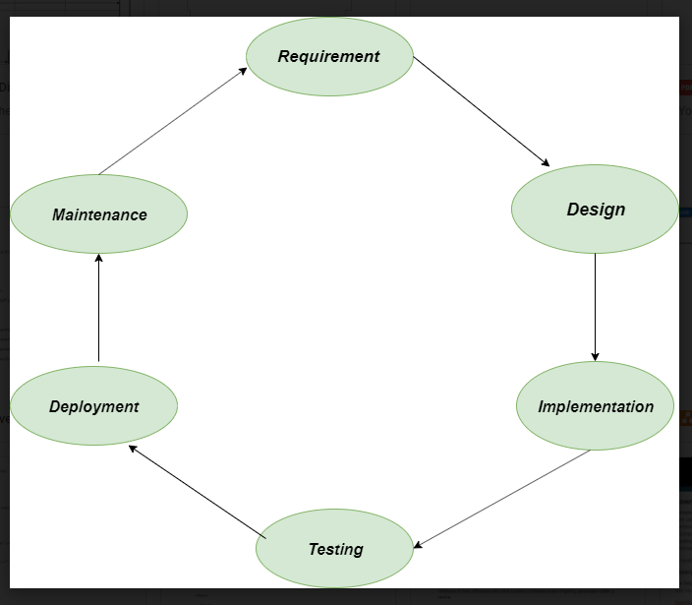

1.Requirement :- This phase involves gathering information about the software requirements from stakeholders, such as customers, end-users, and business analysts.

2. Design: In this phase, the software design is created, which includes the overall architecture of the software, data structures, and interfaces.

It has two steps: High-level design (HLD)

Low-level design (LLD)

3. Implementation or coding: The design is then implemented in code, usually in several iterations, and this phase is also called as Development.

4. Testing: The software is thoroughly tested to ensure that it meets the requirements and works correctly.

5. Deployment: After successful testing, The software is deployed to a production environment and made available to end-users.

6. Maintenance: This phase includes ongoing support, bug fixes, and updates to the software.

4. What is DFD? Create a DFD diagram on Flipkart ?

Ans. A Data Flow Diagram (DFD) is a simple visual tool that shows how data moves through a system, illustrating where it comes from, how it is processed, and where it goes.

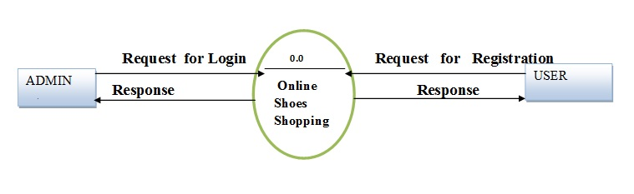

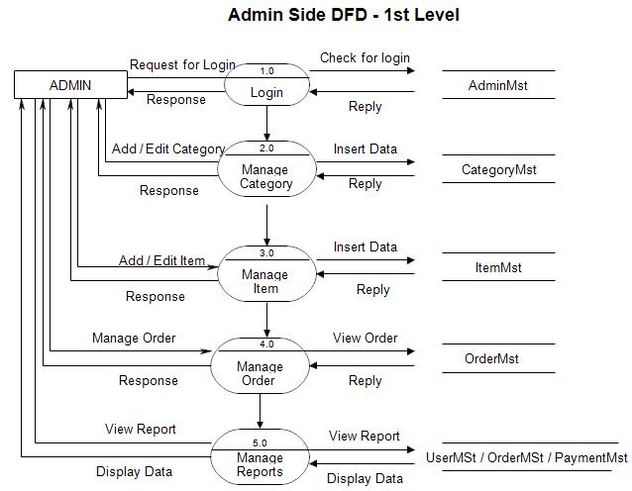

5. What is Flow chart? Create a flowchart to make addition of two numbers.

Ans.

A flowchart is a type of diagram that represents a workflow or process. A flowchart can also be defined as a diagrammatic representation of an algorithm, a step-by-step approach to solving a task.

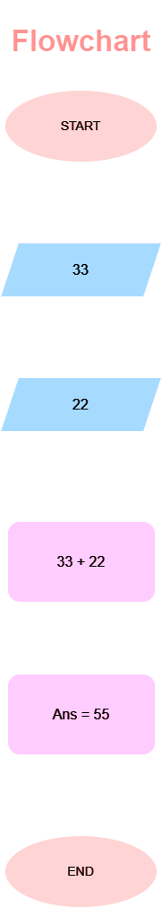

6.What is Use case Diagram? Create a use-case on bill payment on paytm.

Ans.

Simple Use Case Diagram

1.Customer: The primary actor who interacts with the system to pay bills.

2.Use Cases:

* Log in
* Select Bill Type
* Enter Bill Details
* Make Payment
* Confirm Payment
* Receive Payment Confirmation

